Southwest Middle
After School Activities
Booklet

2017-2018

Table of Contents
Table of Contents Page 1-2
Expectations and Guidelines Page 3
After School Activity Information Page 4

Help Sessions
Navigators’ Help Session (6th Grade) Page 5
Explorers 9th Hour (6th Grade) Page 5
Champions 9th Hour (7th Grade) Page 5
Trailblazer Help Session & 9th Hour (7th Grade) Page 5
Westside Wildcats 9th Hour (8th Grade) Page 5
Westside Math Help Session Page 5
Eastside Pride 9th Hour (8th Grade) Page 6
Eastside Math Help Session Page 6
History Help/9th Hour Page 6

Fine Arts
Chamber Orchestra Page 7
Choir Extra Practice Page 7
Fall Theatre Production Page 7
Improv Team Page 7
Jazz and Ensembles Page 8
Spring Theatre Production Page 8

Clubs
Art Club Page 9
AAA / ASAP Club Page 9
“Dig In” Gardening Club Page 9
EcoAction Page 9
Girls in STEM Page 9
Knitting Club Page 10
Magic: The Gathering Club & Card Games Page 10
Math Club/Math Team Page 10
Book Battle Team Page 10
The Combine Page 10
Yearbook Club Page 11
Judo Club Page 11
Step Team Page 11
Dance Team Page 11

Intramurals
Wrestling Page 12
Soccer Page 12
Cross-Country Page 12
Basketball Page 12
Volleyball Page 13
Softball Page 13
Flag Football Page 13
Track & Field Page 13
Bus Routes Page 14

AFTER SCHOOL ACTIVITIES EXPECTATIONS & GUIDELINES

1) During after school activities, we demonstrate the four Core Values: Respect, Perseverance, Compassion & Integrity.
When we attend tournaments/meets, we represent SWM and we need to demonstrate our best sportsmanship. With this comes the expectation that all students perform at their highest level during all activities.

2) Any student staying for an activity MUST sign up for that activity during lunch. No student will be allowed to stay after school for an activity that he/she did not sign up for. Students who stay after school but do not sign up will be required to contact home with an administrator in order to arrange for parent pickup.

For intramurals, if a student shows up a second time to an activity without signing up, they will not be allowed to participate during that intramural season. He/she will need to wait until the next intramural season begins before again participating.

For clubs and other activities, students who stay for an activity for a second time without signing up may be excluded from participating in that activity for a determined period of time at the discretion of the club sponsor and an administrator.

3) Any student assigned to In-School Suspension (ISS) or Out-of-School Suspension (OSS) may not attend any after school activity until the day after that suspension is completed.

4) Coaches decide which students will attend the tournaments. They base much of their decision on:
A) Academic Standing (Includes Homework Completion)
B) Behavioral Standing (Includes Teacher Recommendation and Citizenship Marks in ALL Classes)
C) Attendance for Weekly Intramurals
*Please wear the SWM shirt at all tournaments. You may purchase a SWM shirt at the School Store.

5) Follow the CODE OF EXPECTATIONS
A) BE ON TIME
B) SHOW GOOD SPORTSMANSHIP
•Respect for self, others (students, every adult), and equipment
C) FOLLOW DIRECTIONS
•Everyone must sign up for activity in advance during your lunch period
•BE PREPARED to learn the skills and rules of the intramural sport

6) HELP SESSIONS
•Take priority over all other after school activities.
•Academics come first!

7) CONSEQUENCES
•If you do not follow the Code of Expectations, you may not participate in the present sport and/or not participate in
the next intramural sport .
•If you do not sign up at lunch, you may not participate.

8) In order for students to participate in any after school activities, they must be in class for at least half of the school day. This means, they need to be in school at least until 11:30 a.m. or arrive to school no later than 11:30 a.m.

9) When in doubt, always refer back to #1.

AFTER SCHOOL ACTIVITIES INFORMATION

Time: 3:15-4:25 P.M. (Immediately following dismissal, go to your activity)
Students will begin loading buses at 4:25. The buses will stop close to the student's home, but they will not be making as many stops as the regular bus runs. Please see the bus schedules located in the back of this booklet.

Days: Mondays, Wednesdays, & Thursdays

Sign Up: BE SURE TO SIGN UP FOR ACTIVITIES DURING LUNCH.

Fees: If there is a fee, please pay at the school store. Make checks payable to Southwest Middle School. Most activities do not have a fee; if the activity does, it will be in the description in this booklet.

Changes/Cancellations: The daily announcements will let students know of new clubs/activities and of any cancellations/changes. Students need to be sure to listen to the announcements each day.

Help Sessions

Navigators 9th Hour (6th Grade)
Sponsors: Navigator Teachers Location: Room 102
Meeting Days: Thursdays
Starting Date: September 14 Ending Date: May 10
Description: Students on the Navigators team will be able to get help with homework, projects, reports, and any other academic need. Students may only stay if they have work they need help with. This is not a socializing session.

Explorers 9th Hour (6th Grade)
Sponsors: Explorer Teachers Location: Room 116
Meeting Days: Thursdays
Starting Date: September 14 Ending Date: May 10
Description: If you are a student on the Explorers’ team looking for extra help on homework, needing to catch up on assignments, or wanting to be further taught concepts, please come to our help session!

Champions 9th Hour (7th Grade)
Sponsors: Champions Teachers Location: Room 204
Meeting Days: Mondays
Starting Date: September 11 Ending Date: May 7
Description: Champions 9th Hour is designed to help any Champion student who needs extra time or assistance with core classwork.

Trailblazer Help Session & 9th Hour (7th Grade)
Sponsors: Trailblazer Teachers Location: Room 213
Meeting Days: Thursdays
Starting Date: September 14 Ending Date: May 3
Description: Please join us after school on Thursdays if you are a Trailblazer student wanting support in any of your classes or want a quiet place to work through homework. Meet your teachers in Mrs. Reinhart’s room. Then students will be separated into break-out rooms depending on their needs.

Westside Wildcats 9th Hour (8th Grade)
Sponsors: Westside Wildcat Teachers Location: Room 302
Meeting Day: Mondays
Starting Date: September 11 Ending Date: May 7
Description: Westside Wildcats can stay after school with their team teachers to work on homework, make up work, work on group projects, or get extra assistance on the concepts taught in class. If you are interested in joining us, please don’t forget to sign up at lunch!

Westside Math Help Session
Sponsors: Mrs. Breckenkamp Location: Room 304
Meeting Day: Thursdays
Starting Date: September 14 Ending Date: May 10
Description: If you are an 8th grade Westside math student, join Mrs. Breckenkamp for some extra support to strengthen your math skills. Sign up at lunch for help with homework, missing assignments, or extra support to prepare for tests and retakes. See you there!
Eastside Pride 9th Hour (8th Grade)
Sponsors: Eastside Pride Teachers Location: Room 319
Meeting Day: Mondays
Starting Date: September 11 Ending Date: May 7
Description: The teachers of Eastside Pride require all Eastside Pride students with missing work to attend 9th Hour. This is an excellent opportunity to receive additional support from your teachers. 9th Hour is also open to Eastside Pride students who simply need assistance on completing homework, projects, and other work.

Eastside Math Help Session
Sponsors: Mrs. Hong Location: Room 315
Meeting Day: Wednesdays
Starting Date: October 4 Ending Date: TBA
Description: If you are an 8th grade Eastside math student, join Mrs. Hong for some extra support to strengthen your math skills. Be the first ten to sign up at lunch for help with homework, missing assignments, or extra support to prepare for tests and retakes. See you there!

History Help/9th Hour
Sponsors: Mr. Dueker Location: Room 300
Meeting Day: Thursdays
Starting Date: September 14 Ending Date: May 10
Description: A time and place to get help with any of your World History or U.S. History needs.

FINE ARTS

Chamber Orchestra
Sponsor: Mrs. Sheehan Location: Room 705
Meeting Day: Wednesdays
Starting Date: September (after auditions are complete) Ending Date: May 9
Fee: $15 for a performance t-shirt
Description: Chamber Orchestra is an audition-based orchestra that meets on Wednesdays. Any student in orchestra is eligible to audition. Auditions will take place in early September. Students should see Mrs. Sheehan in Room 705 for audition materials and to sign up for an audition date/time. Mrs. Sheehan will announce the orchestra members online once auditions are completed. Students in Chamber Orchestra will have extra performing opportunities. It is a fun and challenging musical experience.

Choir Extra Practice
Sponsor: Mrs. Kaibel Location: Room 704
Meeting Day: Mondays
Starting Date: TBA Ending Date: TBA
Description: On select Mondays, Mrs. Kaibel will stay after school to rehearse with students in preparation for 7th/8th grade honor choir in January and students performing in the solo/ensemble festival in April. More information on these opportunities will be discussed in choir class.

Fall Theatre Production
Sponsor: Ms. Hetz Location: Room 702
Play Dates: November 16th and 17th, 2017
Informational Meeting: Monday, September 11
Audition Dates: September 18-21
Fee: There is a participation fee. Please see audition information.
Description: The Fall Theatre Production will be a play titled You Can’t Beat the House. A play has a script, actors, costumes, etc. All students who attend Southwest Middle may audition to be in the cast. There will be an informational meeting on Monday, September 11, after school, for anyone who is interested. If you are unable to attend the meeting, you may pick up an audition packet from Ms. Hetz after September 1. Backstage crews for this show consist of: lights, sound, props/running crew, publicity, ushers, make-up and costumes.

Fall Theatre Production Google Classroom Code for the audition form and technical forms: acsmwn7

Improv Team
Sponsor: Ms. Hetz Location: Room 702
Meeting Days: Wednesday
Starting Date: April 4 Ending Date: May 2
Description: Southwest Middle's Improv Team, Multi-Colored Sharpies, is open to everyone who is interested in improvisation. Improvisation is acting without a script. We will learn the basics of improvisation through improv games similar to shows like "Who's Line is it Anyway?" Improv Team is a club that is held during times when there isn't a play happening. Listen to the announcements for Improv Team practices.
Jazz and Ensembles
Sponsor: Mr. Davis Location: Room 707
Meeting Days: Mondays and Thursdays
Fee: $35 for Jazz Band Shirt/Individual Trips
Starting Date: September 11 Ending Date: May 7
Description: Jazz Band is for the student that wishes to perform a lot in a wide range of styles. Emphasis will be placed on public performances and developing skill in a variety of musical styles (Jazz, Rock, etc…). Participation in All Suburban Honor Band auditions and Solo & Ensemble Festival will be stressed. All players need to be enrolled in a band class. Watch for sign up information on the band room door the week before After School Activities begin.
The following instruments are needed:
Woodwinds: Flute, Clarinet, Bass Clarinet, Alto Tenor and Bari Saxes
Brass: Trumpet, French Horn, Trombone , Baritone, Tuba
Rhythm Section: Piano, Bass, Guitar, Drum set, Vibes

Spring Theatre Production
Sponsor: Ms. Hetz
Musical Dates: March 15th and 16th, 2018 Location: Room 702
Informational Meeting: Monday, November 27
Audition Dates: December 11-14
Fee: There is a participation fee. Please see audition information
Description: The Spring Theatre Production will be the musical G2K Rogers and Hammerstein’s Cinderella. A musical is composed of singing, dancing, and acting in order to advance the story. All students who attend Southwest Middle may audition to be in the cast. There will be an informational meeting on Monday, November 27, after school, for anyone who is interested. If you are unable to attend the meeting, you may pick up an audition packet from Ms. Hetz after November 27. Backstage crews for this show will consist of: lights, sound, props/running crew, publicity, ushers, make-up, and costumes.

Spring Theatre Production Google Classroom Code for audition form and technical forms: bdfy3mn

CLUBS

Art Club
Sponsors: Mr. Williams Location: Art Room
Practice Days: Thursdays
Starting Date: September 14 Ending Date: May 10
Description: 7th and 8th grade students will partake in creating art for the art store which sells artwork to students and staff. Also, learn magna art and custom paint apparel.

AAA / ASAP Club
Sponsor: Mr. Daniels, Mr. Vakharia, and Mr. Williams Location: Room 220
Meeting Day: Mondays
Starting Date: September 25 Ending Date: May 7
Description: Come join Mr. Daniels, Mr. Vakharia, and Mr. Williams, your mentors, and other AAA and ASAP students on Mondays after school. You can receive tutoring and /or homework help, build new relationships with your peers and mentors, and learn how to use your gifts and talents to help you succeed on your accelerated path of study. Be sure to sign up at lunch. Please note that this club is by invitation only. See Mr. Daniels or Mr. Vakharia if you have any questions.

“Dig In” Gardening Club
Sponsor: Mrs. Cuba & Mrs. Newsome Location: Room 406
Meeting Day: Wednesdays
Starting Date: September 13 Ending Date: May 9
Fees: Possible field trip
Description: You'll really "dig" working in our gardens and beautifying our campus. We will plant, trim bushes, weed, harvest and cook produce. We will also be working to expand the garden, pollinator garden, build rain catchers, and learn about compost. We will meet every Wednesday in September, October, March, April and May. A great community service club! Remember, a little dirt never hurt!

EcoAction
Sponsor: Mr. Larson Location: Room 207
Meeting Day: Wednesdays
Starting Date: September 13 Ending Date: May 9
Description: Interested in improving and learning more about the space outside the school? Come out and build/clean up our trail system, build the new outdoor classroom, and revitalize the pond area all the while learning about the animals and organisms that inhabit our green space. This club will not be held on days when it rains or it is excessively hot/cold outside.
*Warning* Must not be afraid of a little dirt, sweat, and bugs

Girls in STEM
Sponsors: Mrs. Burger Location: Library
Meeting Day: Thursdays (meet every other Thursday - 1st and 3rd Thursday of each month)
Starting Date: September 21 Ending Date: TBA
Fee: May need to purchase materials or field trip costs
Description: Girls in STEM is a club for girls interested in the science, technology, engineering, and math fields. Participants will immerse themselves in coding, math challenges, building, and other STEM activities. They will also learn from epixperts in the field with guest speakers, virtually or face to face. Passion, innovation, creativity, teamwork, and thinking skills are required!

Knitting Club
Sponsor: Mrs. Douglas and Ms. Stockstrom Location: Room 215
Meeting Day: Wednesdays
Starting Date: September 13 Ending Date: May 9
Fee: $5.00
Description: Learn to knit is for anyone who wants to learn to knit. This year, there will only be openings for 8 students at a time. We will be making our needles this year and a scarf. You MUST be willing to be committed to coming every week while working on the project. As the year progresses, we will add new students to the group after a group has been together for at least six weeks.

Magic: The Gathering Club & Card Games
Sponsor: Mr. Vakharia Location: Room 410
Meeting Day: Thursdays
Starting Date: September 14 Ending Date: May 10
Description: Join us for some popular card games including Magic: The Gathering and Yu-Gi-Oh! Players of all skill levels are welcome, and new players are encouraged to come by and check out this club!

Math Club/Math Team
Sponsor: Ms. Hendricks and Mrs. Otten Location: Room 706
Meeting Day: Thursdays
Starting Date: October 5 Ending Date: April
Description: Math Club will meet on Thursdays in room 706. We will do math activities, solve problems, and prepare for various contests throughout the school year. Please join us if you are interested.

Book Battle Team
Sponsor: Mrs. Burger Location: Library Classroom
Meeting Day: Wednesdays
Starting Date: September 13, future dates TBD Ending Date: TBA
Fee: Cost of Book Battle T-shirt ($10-$15)
Description: Students participating in this club have the opportunity to compete in the St. Louis Area-Wide Book Battle against other middle schools. Participants must commit to reading ALL the books on the Book Battle list (20 titles) and be willing to meet during lunch to practice and study the details of the books. We will meet once a month after school until March. Then we will meet every Wednesday.

The Combine
Sponsors: Mr. Sheets and Mr. Kilgore Location: Room 319
Meeting Day: Wednesdays
Starting Date: September 13 Ending Date: Winter Break
Description: This after school activity will focus entirely on the sport of football. This activity is open to all 8th grade students. Students will draft and manage a fantasy football team, competing against other students and teachers for the league title. Students will also play flag football, incorporating various offensive and defensive schematics. Lastly, students will hone their skills in the gym while participating in weight training and conditioning drills.
Yearbook Club
Sponsor: Ms. Jung Location: Room 218
Meeting Day: Wednesdays
Starting Date: September 13 Ending Date: Spring Break
Description: Participating in the Yearbook Club is a fun way to express your creativity! The yearbook consists of about 80 pages of design layouts, pictures, and writings that hold countless memories of the middle school students, teachers, and administrators here at Southwest. Creating this yearbook will take many hours and much dedication from well-organized individuals willing to stay after school every week. If you have the writing skills, the artistic skills, the organizational skills, and the people skills needed to create a priceless piece of Southwest’s history, AND you are willing to attend weekly meetings on a regular basis, then Yearbook Club is for YOU! Space is limited, so each member must maintain excellent citizenship, grades, and attendance!

Judo Club
Sponsor: Mr. Daniels Location: Peggy Terry Commons
Meeting Day: Wednesdays
Starting Date: October 4 Ending Date: May 9
Description: Come learn the basics of Judo! You will learn discipline, how to fall, take downs and hold downs. A judo gi (uniform) is not necessary but definitely helpful. Everyone is welcome!

Step Team
Sponsor: Mrs. Byrd Location: Room 107
Meeting Day: Wednesdays
Starting Date: September 13 Ending Date: May 9
Description: Stepping is a rising art form and an important part of America’s artistic and cultural heritage. In stepping, the body is used as an instrument to create intricate rhythms and sounds through a combination of footsteps, claps and the spoken word (more on the evolution of step from Step Afrika - http://www.stepafrika.org/company/what-is-stepping/ )
Your child will learn a short step routine, a short poem and a short stroll (similar to a line dance). He/She will demonstrate their ability to execute what was learned during practice in groups of 4 during the actual tryout date on Saturday, September 23rd.
Steppers will be observed throughout tryouts on character, ability to learn, enthusiasm, projection and overall performance. We will be looking for their ability and potential to become a proud and dedicated Parkway District Stepper. We are a traveling competition and performance team with scheduled events throughout the school year.

Dance Team
Sponsor: Mrs. Byrd Location: Room 107
Meeting Day: Mondays
Starting Date: November 27 Ending Date: May 7
Description: Do you love dancing? If so, students of any age are welcome to join the Dance Team. We meet each Monday afternoon in Mrs. Byrd’s room. Hope to see you there!

INTRAMURALS

Wrestling
Sponsor: Mr. Mickley Practice Location: Small Gym
Practice Days: Mondays
Starting Date: September 11
Tournament Date/Time: October 16 at 3:30
Tournament Location: West Middle School

Soccer
Sponsors: Mr. Ribeiro, Mrs. Reinhart, Mr. Fennessey, and Mr. Kilgore
Practice Location: Large Gym
Meeting Days: 6th Grade: Mondays 7th Grade: Wednesdays 8th Grade: Thursdays
Starting Date: September 11
Tournament Dates Location/Time: 3:30 Start Time (Depending on Bracket)
6th Grade: October 23 at Parkway Northeast Middle School
7th Grade: October 23 at Parkway Northeast Middle School
8th Grade: October 18 at Parkway West Middle School
Rain Makeup Date: October 25

Cross-Country
Sponsors: Mrs. Chambliss, Mrs. Phillips, and Mr. Williams
Practice Location: Peggy Terry Commons
Practice Days: Mondays and Wednesdays
Starting Date: September 11
Tournament Date/Time: October 30 at 4:00
Tournament Location: Parkway South Middle School
Practice Race: October 10 at Parkway Central Middle School
Rain Makeup Date: November 1

Basketball
Sponsors: Mr. Ribeiro, Mr. Houchins, & Mrs. Sheets
Practice Location: Large Gym
Practice Days: 6th Grade: Mondays 7th Grade: Wednesdays 8th Grade: Thursdays
Starting Date: Week of October 30
Tournament Dates/Locations/Times: 3:30 Start Time (Depending on Bracket)
6th Grade: December 18 at Parkway Northeast Middle School
7th Grade: December 18 at Parkway South Middle School
8th Grade: December 20 at Parkway West Middle School

Volleyball
Sponsors: Mr. Ribeiro, Mr. Houchins, Mr. Sheets & Mrs. Sheets
Practice Location: Large Gym
Practice Days: 6th Grade: Mondays 7th Grade: Wednesdays 8th Grade: Thursdays
Starting Date: January 8
Tournament Dates/Times: All tournaments will begin at 3:30
Tournament Location: Parkway Southwest Middle School
6th Grade: February 21 7th Grade: February 21 8th Grade: February 22

Softball
Sponsors: Mr. Ribeiro, Mr. Houchins, and Mr. Sheets
Practice Location: Large Gym
Practice Days: 6th Grade:Thursday 7th & 8th Grade: Monday & Wednesday
Starting Date: February 26
Tournament Dates/Times: All tournaments will begin at 3:30
Tournament Location: Parkway South High School
6th Grade: April 9 7th Grade: April 9 8th Grade: April 11
Rain Makeup Date: April 12

Flag Football
Sponsors: Mr. Ribeiro and Mr. Houchins
Practice Location: Large Gym
Practice Days: 6th Grade: Mondays 7th Grade: Wednesdays 8th Grade: Thursdays
Starting Date: March 12
Tournament Dates/Times: April 16 at 3:30
Tournament Location: Parkway Central Middle School
Rain Makeup Date: April 17

Track & Field
Sponsors: Mrs. Chambliss, Mrs. Phillips, and Ms. Dressel
Practice Location: Large Gym
Practice Days: Wednesdays
Starting Date: April 4
Tournament Date/Time: May 17at 9:00 a.m.
Tournament Location: Parkway North High School
Rain Makeup Date: May 18

Purple Bus Route
Bus # 14
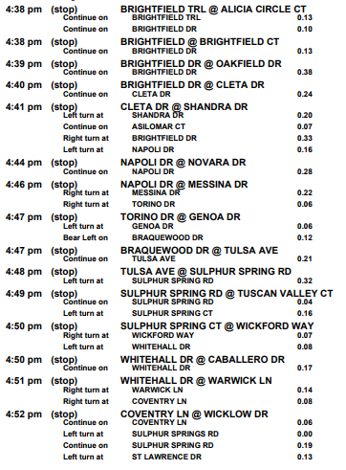
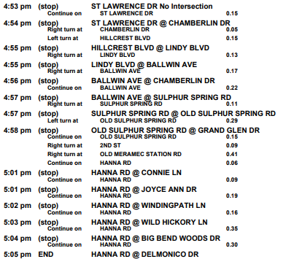

Green Bus Route
Bus # 73
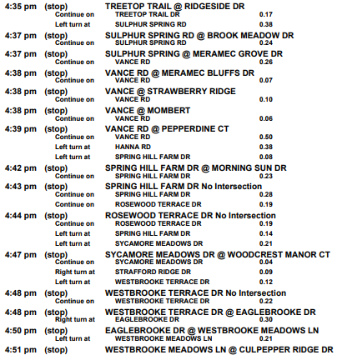
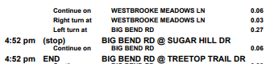

Red Bus Route
Bus # 83
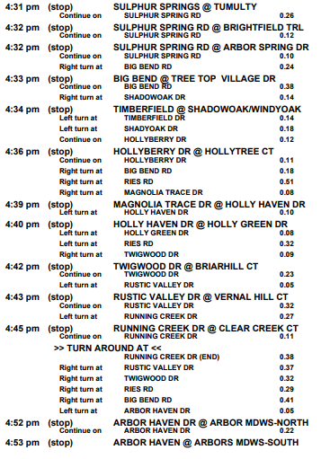
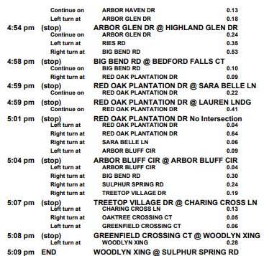

Bus Route for St. Louis

TBD

